Isolating an M35A3 tire from the Central Tire Inflation System
This article focuses on making each tire independent of the always leaky CTIS components. The basic theory is to isolate the tire, remove as many leak points as you can, and install a standard Schrader valve for manual control. I opted to leave all the upstream CTIS components in place. They serve no purpose now, but have no effect on performance and I simply don’t want to go to the effort of removing them at this time.
If you include shipping costs from Erik’s, I spent $25 per tire.
Tools needed:
Safety glasses, gloves, ear protection
3/4” impact with 1-1/2” and 1-1/8” sockets
wrenches
wire brush/wire wheel
prybars
BFH
liquid soap
Parts needed:
I ordered the CTIS items below from www.eriksmilitarysurplus.com and you can pick up the bushings from any hardware store. You will need 1 set for each tire. The brass mounting nut is not required, but it’s a good idea in case you mess up the old one with your wrench. They’re cheap, too!
Rim O-Ring | Valve Stem Grommet | Rim Stem Mounting Nut
Item #12363606 | Item #RG22 | Item #HN80
$12.75 | $3.75 | $3.80
3/8” x 1/4” Hex bushing | 1/4” x 1/8” Hex bushing
$2.38 | $1.64
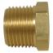 | 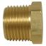

Step 1: Remove tire
Remove 2 nuts and 2 hub bolts holding CTIS cover plate. Discard cover plate. Remove lug nuts with impact driver and 1-1/2” socket. Check to see if they are reverse thread. There will be an “L” stamped on each lug stud if so. Caution! These tires and wheels weigh 382lbs each. Enlist a friend to help.
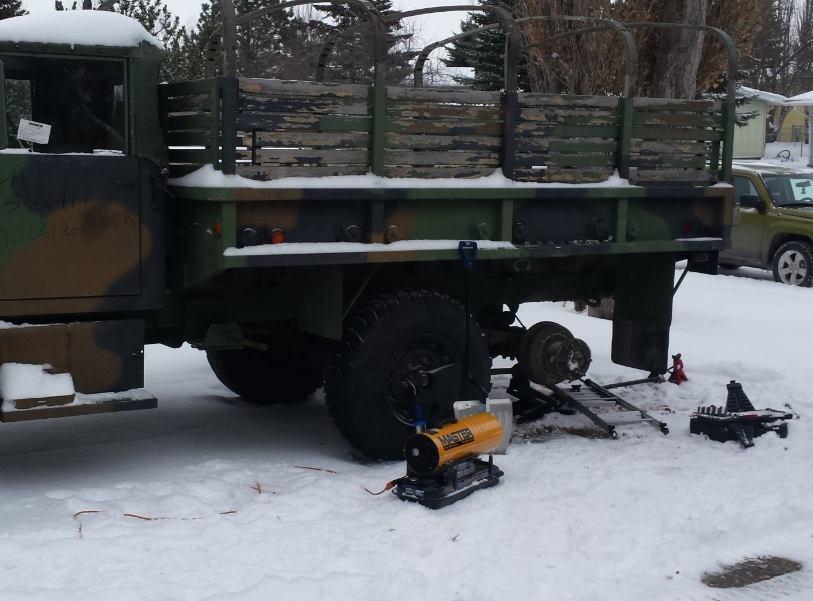
Figure 1: Properly chock and jack the truck to prepare for tire removal. Maybe stretch out too.
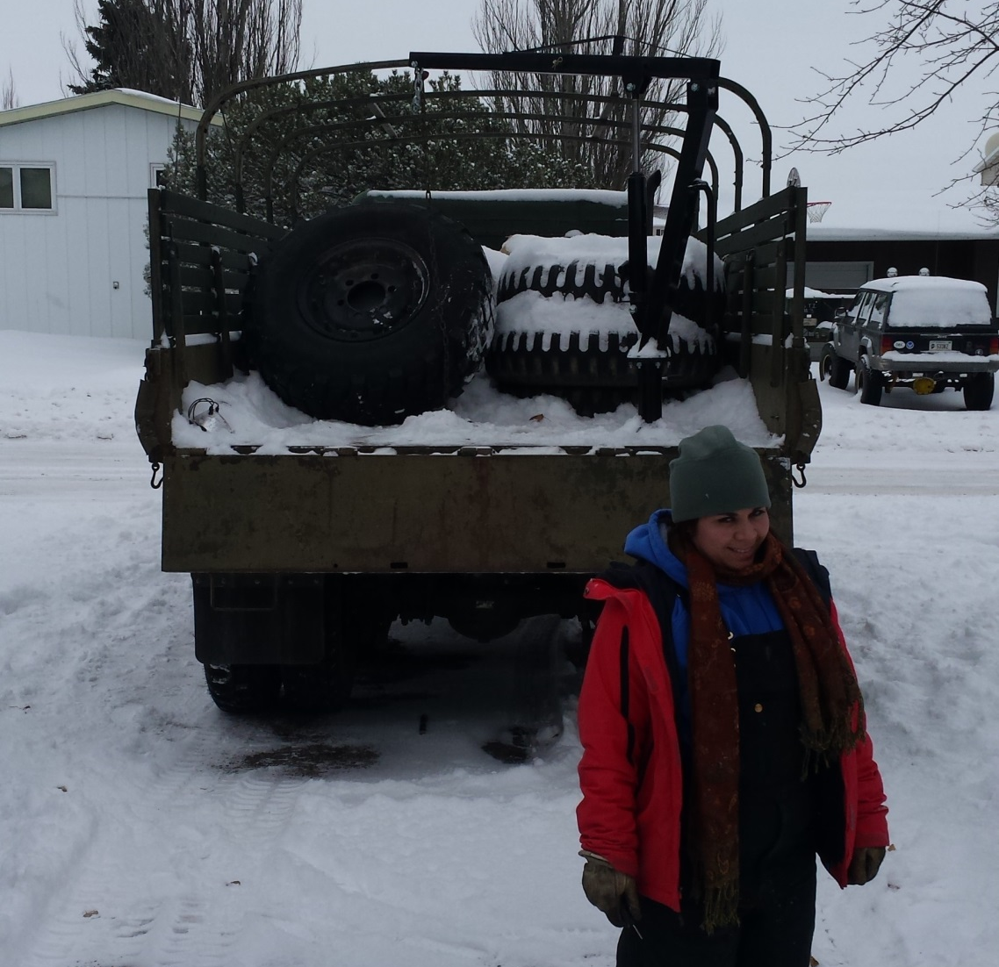
Figure 2: Use nifty crane in much superior M35A2 to haul tire off to fancy warm shop with big tools.

Step 2: Remove CTIS components
Caution! Deflate tire COMPLETELY. Then use 7/8”, 13/16”, and 11/16” wrenches to crack the air lines open. Start where the red arrows are pointing in Figure 3. Next, remove the 2 nuts (yellow arrows) holding the wheel valve in place. Discard the wheel valve and air lines. Then you can remove the elbow fittings from the wheel stud and pipe stem. Keep the Schrader valve (blue arrow) from the wheel valve and the elbow (green arrow) from the pipe stem for later. Also, remove and discard counterweight on opposite side of rim at this time.
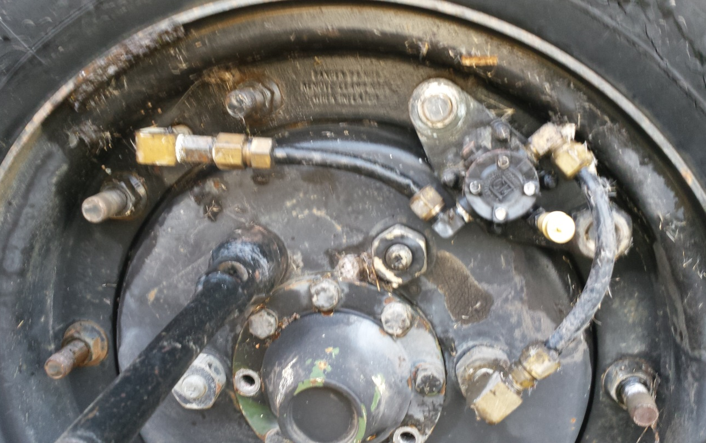
Figure 3: Remove CTIS components, but save two for later. Sorry for all the arrows!

Step 3: Dismount tire from rim
Use a 3/4" impact driver with 1-1/8” socket to remove 10 nuts on the outer ring. Lubricating the studs will help. Then use whatever you have available to break the bead. Once you get ring out, flip the tire over and get the large rim out. Good luck! The first time I did this, I used a pry bar, pickle fork, and garden trowel thingy. The second time, I used a forklift. Choose your own destiny.
Once you break the bead, put something (wood block, jack stand, small child) under the wheel to raise it off the ground, but let the rubber hang free so you can push the tire down as you work your way around the bead with pry bars.
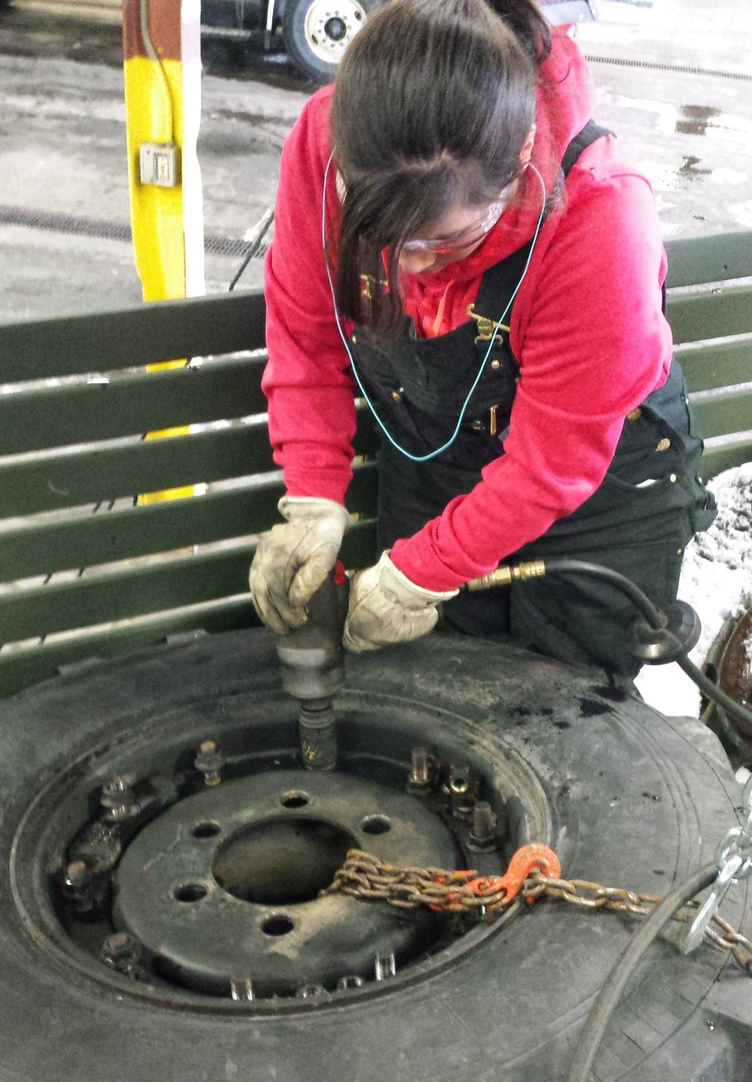
Figure 4: Remove 10 nuts from ring. Good luck. This may take a while!

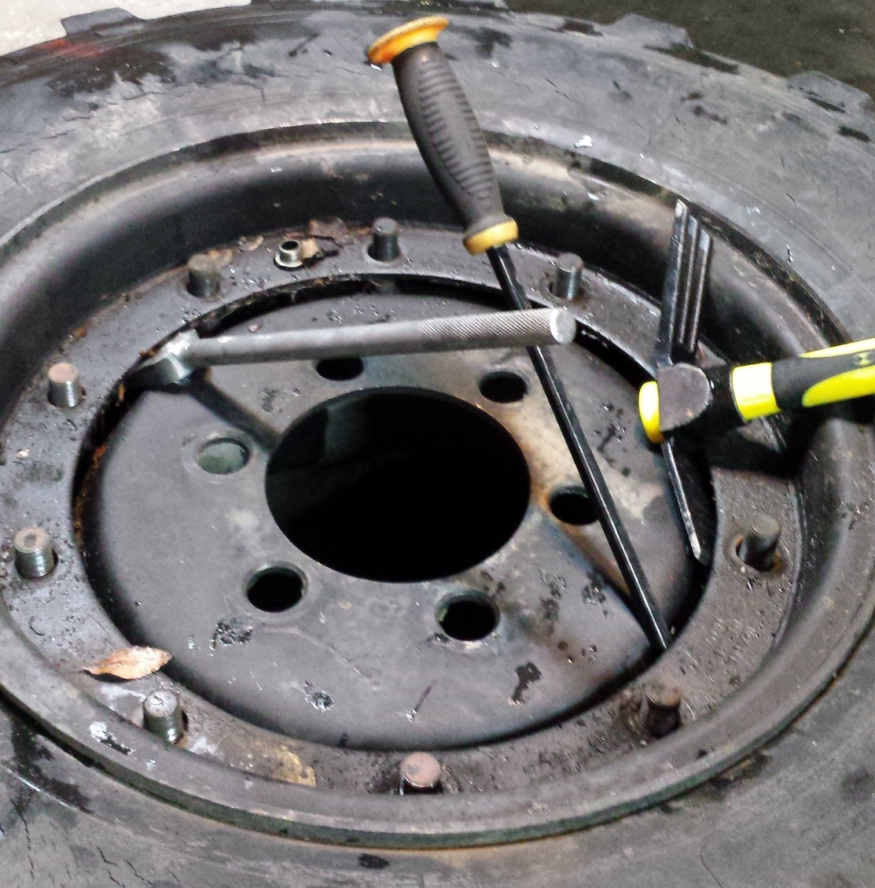
Figure 5: Break the bead however you want. I obviously had no idea what I was doing the first time.
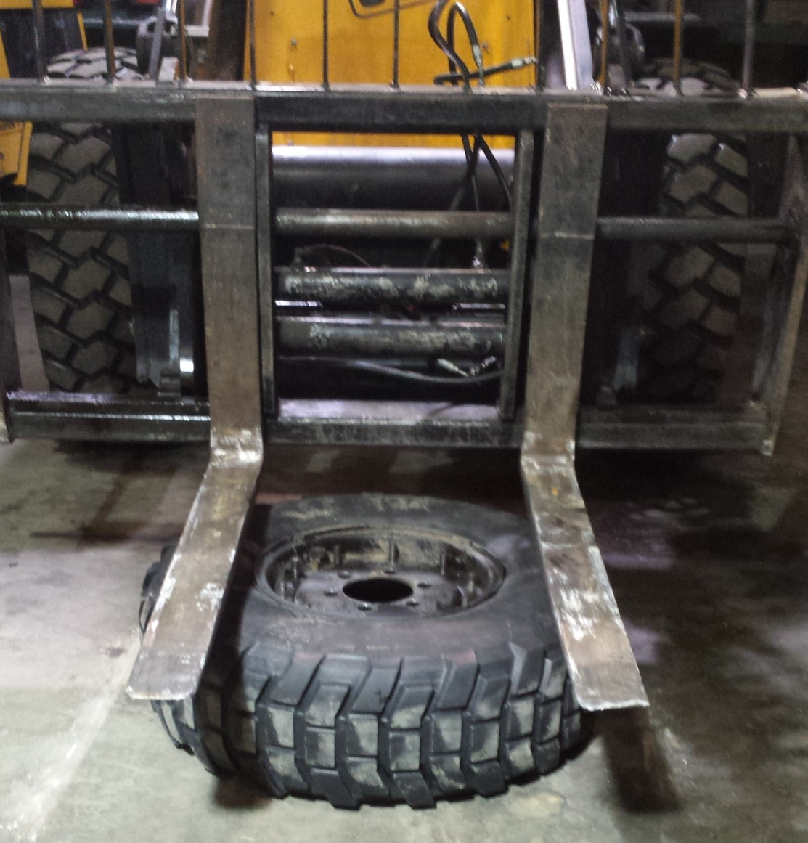
Figure 6: I got smarter the second time.

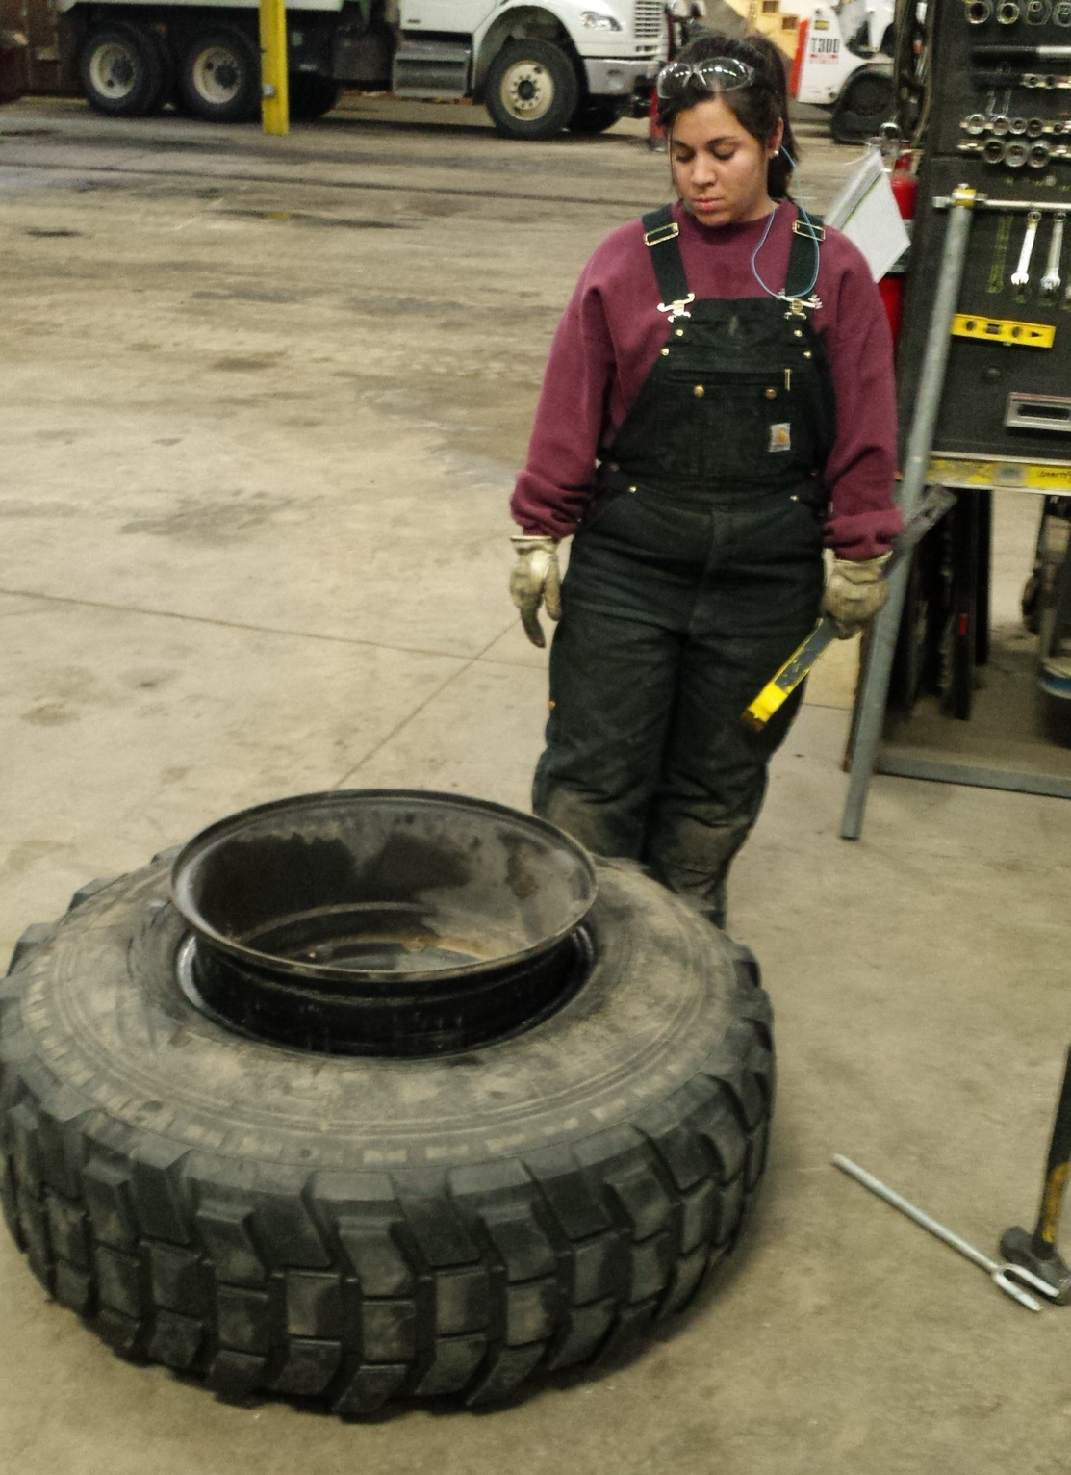
Figure 7: Flip tire over and get that sucker out!

Step 4: Clean and prep rim.
Remove the pipe stem from the wheel using a wrench on the brass nut. Discard the nut and rubber grommet. Also discard the 20-inch o-ring. Use a wire wheel or wire brush and maybe some brake parts cleaner to clean the surface of the wheel where the new rubber will seat.
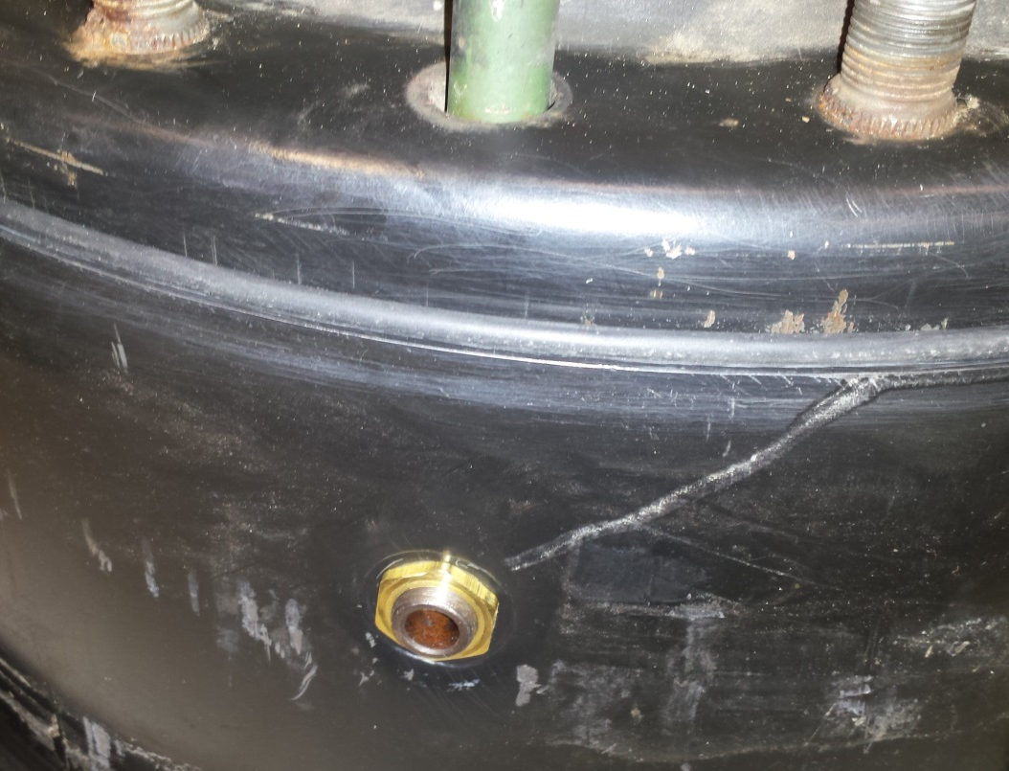
Figure 8: Remove brass nut and pull out pipe stem.

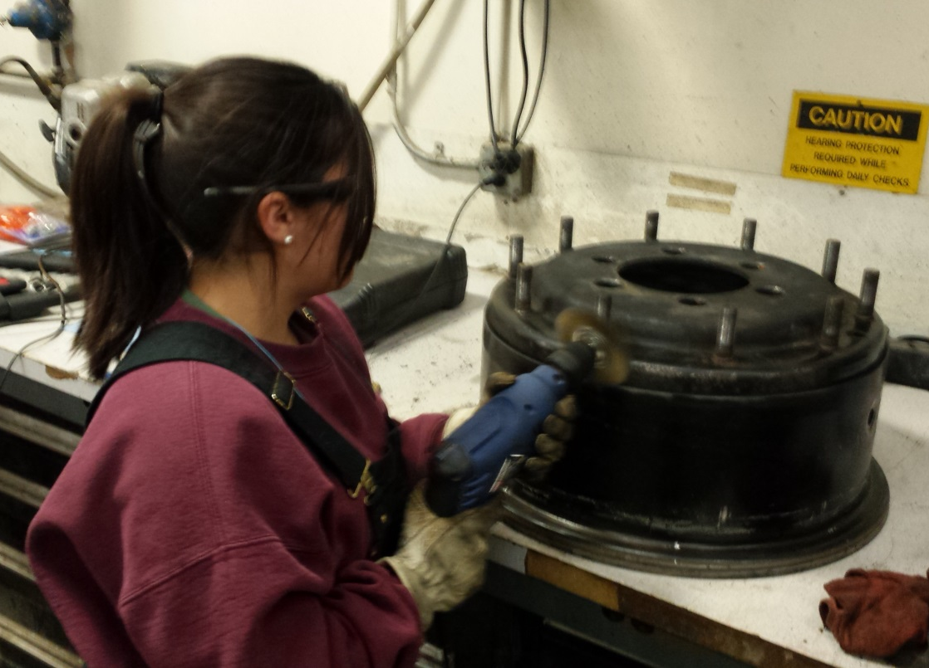
Figure 9: Clean 20-inch o-ring seating.
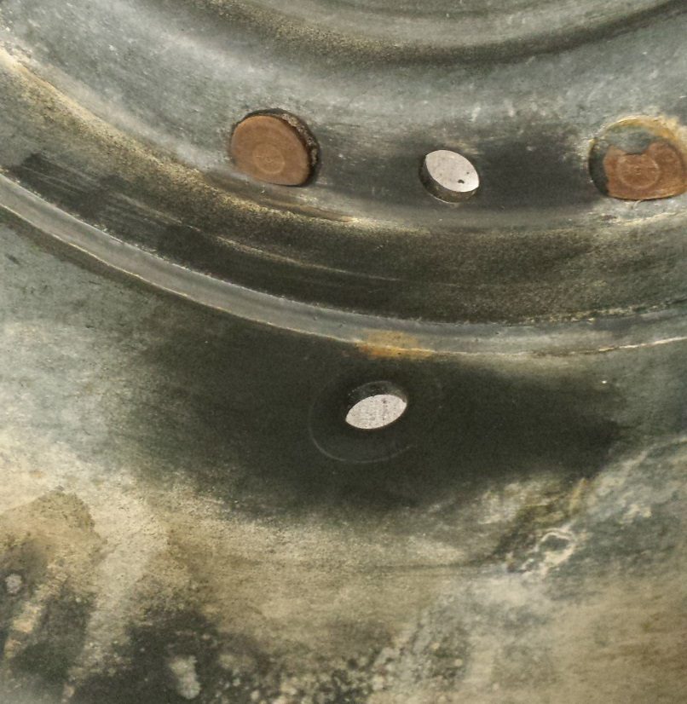
Figure 10: Clean hole for pipe stem grommet.
Step 5: Reassemble!
Put new 20-inch o-ring in the slot on the large rim. The small rim ring will mate to this as shown in Figure 11. Then install new rubber grommet on pipe stem. Re-insert pipe stem in wheel and use brass ring to lock in place.
When ready to mount tire to the rim, use a little dish soap on the bead to help it slip on. This part is very easy with the right lube. NOTE: If your tire tread pattern looks backwards (as 50% of tires are on these trucks), now is the time to flip the tire over to face the correct direction.
Ensure you align the pipe stem to the channel in the inner tire wall before sliding the rim down in place. You will see it. After the two rim halves are together and you feel that the 20-inch o-ring is seated properly, thread the 10 nuts back onto the studs and use the 3/4” impact to drive the rim together. Use a star-like pattern to ensure an even seat.

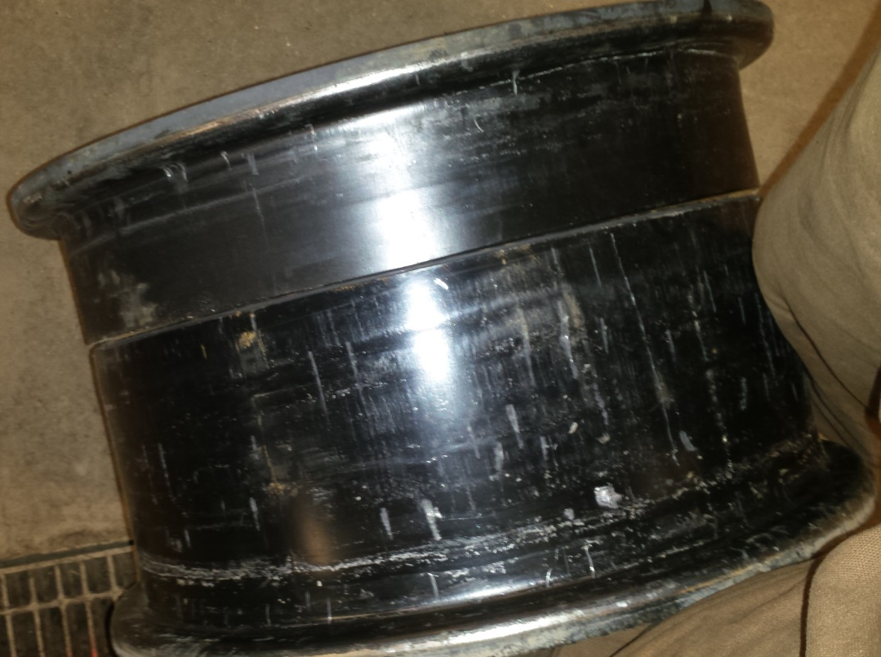
Figure 11: For reference only: This is what a 2 piece rim looks like. A 20-inch o-ring fits between halves.
Figure 12: Install new rubber grommet and brass nut on pipe stem.

Step 6: Modify!
Okay, so up to this point, all you have done is rebuild the seals in the 2 piece rim. You have two choices: 1) Reassemble the CTIS components back to their original state or 2) Eliminate CTIS and follow me on a magical adventure.
Glad you chose #2. Go ahead and reinstall that pipe stem elbow you saved from Step 2. Now pull out the two bushings you picked up from a hardware store. The elbow should be 3/8” NPT and the Schrader valve you pulled off the wheel valve should be 1/8” NPT. Assemble the bushings and Schrader valve as shown in Figure 13. I chose to use Teflon tape on the threads, but it’s brass and should flex a little to make a good seal. Whatever…it’s up to you.
After you feel everything is sealed tight, it’s time to air up the tire. I run my rears at 40psi when empty, so I wasn’t too afraid of explosive failure. Once you have it aired up, this may be a good time to use soapy water to check for leaks.
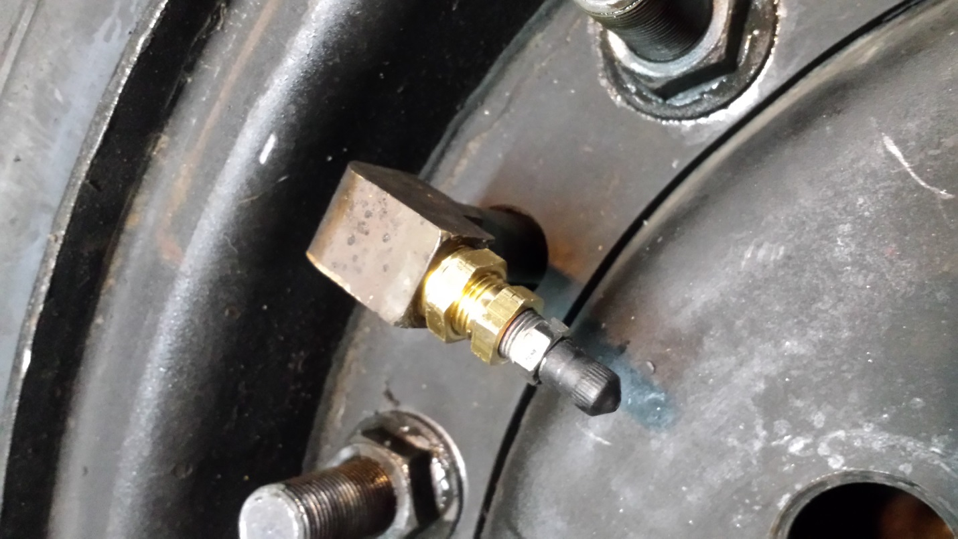
Figure 13: Use bushings to reduce from elbow to Schrader valve.

Step 7: Put the tire back on and rage!
Ask a friend to help put the tire back on your deuce. Don’t forget that the lug studs may be reverse thread depending on which side of the truck you’re on. There is no need to reinstall the counterweight, wheel valve, or cover plate. Turn them into some sort of table centerpiece. You can see the difference between old and new in Figure 14.
Please be safe when working with power tools. I hope this technical write-up helps! If you see any mistakes or have any questions about this write-up, please feel free to contact me. I am Steel Soldiers username JonMolander.
-Zach Bierhaus (not Jon)

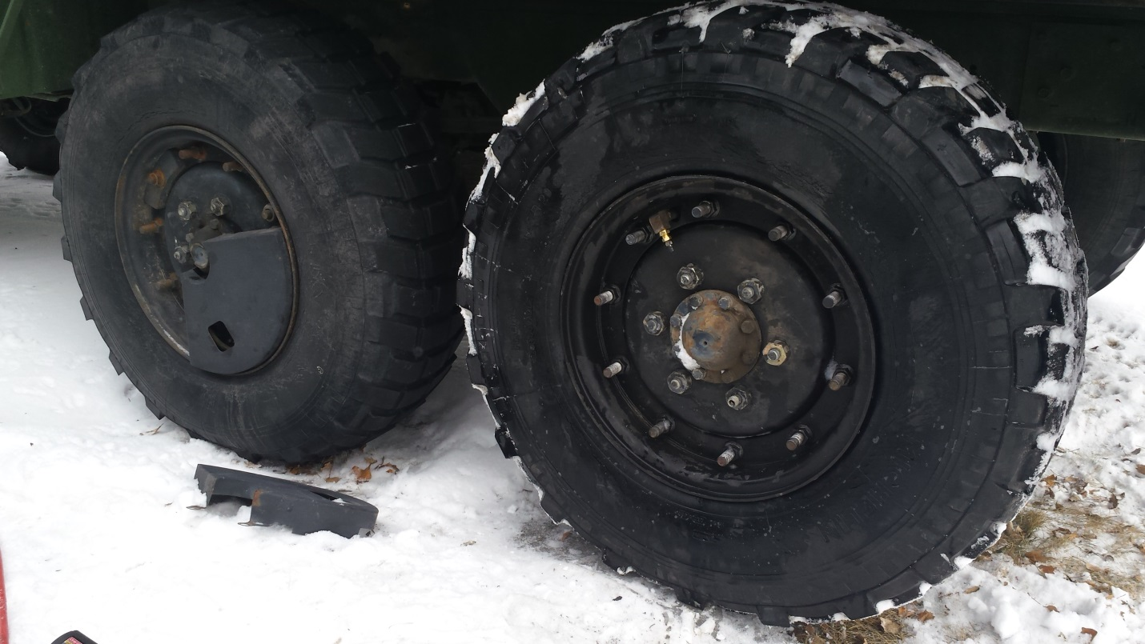
Figure 14: Only 5 more plus a spare to go!

